Final Project

Student Name: Shannon Keeney
Colorado Mountain College
Data Analytics Certificate/Minor
DAT 2002: Visualizing Data Professor: Dr. Rafael Perez Date:
12/12/2025
Outline

- Introduction…………………………………………3
- Data…..…………….………………………………..4-5

- Exploratory Data Analysis (EDA) ………………..5
- Findings & Conclusion…………………..…………5-6

- References…………………..………………………7
- Appendix 1 – One-pager Document…..……..……8-9
- Appendix 2 – Data Coding…..…………….………10-11

- Introduction

After wolves were extirpated in Yellowstone National Park in 1926, herbivores, like elk, lost a natural predator. Elk would overgraze vegetation in some areas of the park. This led to the erosion of streams and lack of food and shelter for other species that depended on plant growth. The reintroduction of wolves in 1995 and 1996 was important to help manage the elk population. The reintroduction of the predator greatly improved the grazing impact of elk in Yellowstone. Without wolves, elk would eventually reach their carrying capacity in the ecosystem. Yellowstone used to be home to about 20,000 elk but the abundance has fallen to as few as 5,000 since the reintroduction. (Smith et al., 2020). The purpose of this project is to examine the relationship between the Yellowstone wolf population and the elk population. This project will compare the predicted elk count to the population count of wolves. Since fluctuations in predator and prey populations impact the other, it is suspected that when elk populations increase the predator population will follow. Then when elk populations decline, wolf populations will decline. This project will visually analyze if Yellowstone wolves and elk follow the same pattern. This project will also determine if inferences can be made about the elk population based on the wolf population.
Understanding the relationship between predator and prey populations is important to making informed decisions. It is also important because the reintroduction of an extirpated species impacts the entire ecosystem. This project is relevant in the real-world context because biologists nationwide are researching into the reintroduction of extirpated predators to restore the natural environment. The reintroduction of wolves in the Greater Yellowstone Ecosystem (GYE) is one of the most famous examples of the importance of natural predator reintroduction to an ecosystem they were extirpated from. The reintroduction reestablished a trophic cascade through the entire ecosystem. The wolves are a key to the food web to control the elk population. (Smith et al., 2020).
- Data

The data that is being used for this project is from the Greater Yellowstone Ecosystem from 1995 to 2022. This data was collected by biologists and technicians in Yellowstone National Park and surrounding National Forests. I am using four variables for this project, the first is “D” for date, this is the date the wolf died. The second variable is “WC” for wolf count, this is the number of Yellowstone National Park resident wolves on December 31. The third variable is “S” for season, this is for the season of mortality, summer is February 1 to August 31, and winter is September 1 to January 31. The fourth variable is “PED” for predicted elk count (10^-3), this is the annual predicted elk abundance. (Cassidy et al. 2024). The frequency of the data collected is based off wolf mortality, there is not a specific frequency this data was collected. In this analysis the average wolf count and predicted elk count were taken from 1995 to 2022.
The data was accessed from the database DataONE, the article is Harvest of transboundary gray wolves from Yellowstone National Park is largely additive by Cassidy et al. The data was downloaded from DRYAD, accessed from a link listed at the top of the DataONE website on this article. The data can be downloaded from https://doi.org/10.5061/dryad.x3ffbg7tc. It is available under the “Data Files” box located near the top of the website. The dictionary for this data set was also accessed under “Data Files”.
The data I am using for this project is cross-sectional data. Each row in my dataset is at a given time based on when an individual Yellowstone wolf died. In the “Raw Data” tab of my Excel file, there is a column labeled “W ID”, this stands for Wolf ID, each individual wolf in this dataset has a unique ID. This ID was given when the wolf was captured and collared for remote tracking. The tracking devices that biologists place on wildlife give off a mortality signal when the collar stops moving because the device falls off or the wolf is dead. Once that mortality signal is heard by the biologist, they will locate the collar. There is not a uniform period when these investigations occur like in time series data, the investigation occurs when the individual is perceived dead and the data is collected based on the individual. There were 177 observations in this data. In order to make the graphs cleaner, the average of each year was taken.

- Exploratory Data Analysis (EDA)

The most applicable of the summary statistics are the minimum value, maximum value, range, and standard deviation. The wolf count has a minimum of 51 and a maximum of 174, that gives the population a large range. The wolf count has a standard deviation of 28.6. I knew that this data varied a lot, but I was surprised by the standard deviation for the wolf count, 28 wolves is significant. The predicted elk count has a minimum of 4 and a maximum of 15, also giving the population a large range. The predicted elk count has a standard deviation of 3.1. The mean is also interesting to see for both variables. I do not think the mode is applicable because the observations are based on wolf mortality and not at specific time periods.
This project will examine the oscillation of the wolf and elk population to determine if there is any correlation between the two. The predicted elk count maximum was at the beginning of this study, while the wolf count minimum was at the beginning of the study. It appears that the predicted elk count lowers when the wolf count is high, and the wolf count lowers after the elk count lowers.
- Findings and Conclusion

Following Tufte’s principles is essential in creating a graph to ensure it has integrity. We want to make sure our visual representations of data are telling the truth. (Andrewtk, 2020). Tufte has six principles for data visualization: proportional representation, clear and detailed labeling, show data variation over design variation, use standardized units for time-series data, match variable dimensions to data dimensions, and maintain contextual integrity.
These six principles are applicable to my visualizations. I am struggling to ensure that one principle is met, matching variable dimensions to the data dimensions. This principle states that only one axis is used for x and y. Since the data I am comparing in this project are very different, the predicted elk count is not accurately represented when it is scaled to the wolf count. Because of this, I created two graphs with two y-axes. This allowed the data to be scaled for comparison, but it can be confusing for the audience. To mitigate this, I created the two graphs again, one on top of the other, with the same x-axis but different y-axis in a separate graph. This allowed the data to be compared without compromising the readability of the graphs. I used the average data in these to have standardized units of time. I believe that these two graphs are better than the one with two y-axes and meet all Tufte’s principles and ensure that the data is properly scaled for comparison. This allowed me to see that overall, there is a correlation between the two populations, there are instances where there isn't a correlation, like in 2018.

- Findings & Conclusion

After Yellowstone wolves were reintroduced in 1995 and 1996, the elk population has been on a downward trend. Throughout the 27 years in this study, the populations oscillate with one another. When there is an increase in the elk population, there is also an increase in the wolf population. This is then followed by a decrease in both populations. But in 2009 both populations stabilized and have had small fluctuations since then. This project visually analyzed the population trends; further analysis is needed to confirm these insights.

- References

Andrewtk. (2020, August 28). Tufte’s principles. thedoublethink.
https://thedoublethink.com/tuftes-principles-for-visualizing-quantitative-information/
Cassidy, B., Smith, D. W., Cassidy, K., Stahler, D., & Hebblewhite, M. (2024). Harvest of
transboundary gray wolves from Yellowstone National Park is largely additive. Journal of Applied Ecoloy, 61(9), 2180–2193. https://besjournals.onlinelibrary.wiley.com/doi/full/10.1111/1365-2664.14720
Greater Yellowstone Ecosystem - Yellowstone National Park (U.S. National Park Service).
(n.d.). https://www.nps.gov/yell/learn/nature/greater-yellowstone-ecosystem.htm
History of wolf Management - Yellowstone National Park (U.S. National Park Service).
(n.d.). https://www.nps.gov/yell/learn/historyculture/wolf-management.htm
Smith, D. W., Stahler, D. R., & MacNulty, D. R. (2020). Yellowstone Wolves: Science and
Discovery in the World’s First National Park. University of Chicago Press.

\

- Appendix 1 - One-Pager

An Examination of the Relationship of Yellowstone Wolf and Elk Populations

After wolves were extirpated in Yellowstone National Park in 1926, herbivores, like elk, lost a natural predator. Elk would overgraze vegetation in some areas of the park. This led to the erosion of streams and lack of food and shelter for other species that depended on plant growth. The reintroduction of wolves in 1995 and 1996 was important to help manage the elk population. The reintroduction of the predator greatly improved the grazing impact of elk in Yellowstone since wolves manage elk populations better than resource availability. Without wolves, elk would eventually reach their carrying capacity in the ecosystem. Yellowstone used to be home to about 20,000 elk but the abundance has fallen to as few as 5,000 since the reintroduction. (Smith et al., 2020).
The purpose of this project is to examine the relationship between the Yellowstone wolf population and the elk population. This project will compare the predicted elk count to the population count of wolves to see if there is a correlation between the two or if population trends are found.
The population counts are the average for each year between 1995 and 2022. Although, this data was collected based on the mortality of a Yellowstone wolf, it created clearer graphs to use the average.

Cassidy et al., 2024
Graph 1 shows the average wolf count and the predicted elk count (10^-3) from 1995 to 2022, the left y-axis is for the wolf count, and the right y-axis is for the predicted elk count. The populations stabilize in 2009. The dotted lines are trendlines.
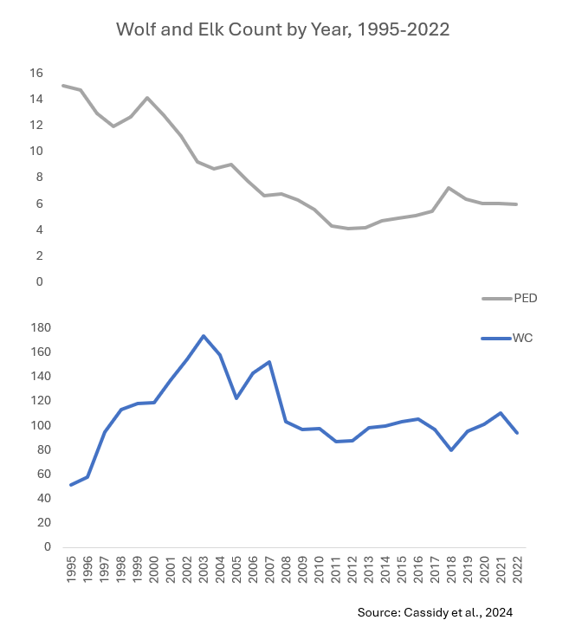
Graph 2 shows the average wolf count and the predicted elk count (^-3) from 1995 to 2022 on two graphs with the same x-axis and 2 y-axis. This allows the wolf and elk count to be properly scaled while also being compared. It shows that after Yellowstone wolves were reintroduced, the elk population has been on a downward trend. It also shows that after small spikes in the elk population that there is also a small spike in the wolf population. Which then is followed by a small decrease in both populations. Both populations leveled out in 2008 and have had small fluctuations since then.

- Appendix 2 - Code

This is the first code in Python, but the y-axis was too large of a scale to show the fluctuations in the predicted elk count.

plt.figure(figsize=(10, 6))

sns.lineplot(
data=df_long,
x='Y',
y='Value',
hue='Line',
linewidth=2.5,
palette=['blue', 'gray']
)

plt.title('Wolf and Elk Count by Year, 1995-2022', fontsize=14, pad=20)
plt.ylabel('Population Count', fontsize=12)
plt.xlabel('')
plt.ylim(0, 180)
plt.figtext(0.5, 0.01,
"Source: Cassidy et al., 2024",
wrap=True,
horizontalalignment='center',
fontsize=9)
plt.show()

This is the final code, which added a second y-axis on the right to scale the predicted elk count appropriately.

fig, ax1 = plt.subplots(figsize=(10, 6))

COLOR_WC = 'blue'
COLOR_PED = 'gray'

sns.lineplot(
data=df_wide,
x='Y',
y='WC',
label='WC',
linewidth=2.5,
color=COLOR_WC,
ax=ax1
)

ax1.set_ylabel('WC (Wolf Count)', fontsize=12, color=COLOR_WC)
ax1.set_xlabel('Year', fontsize=12)
ax1.set_ylim(0, 180)
ax1.tick_params(axis='y', labelcolor=COLOR_WC)

ax2 = ax1.twinx()

sns.lineplot(
data=df_wide,
x='Y',
y='PED',
label='PED',
linewidth=2.5,
linestyle='--',
color=COLOR_PED,
ax=ax2
)

ax2.set_ylabel('PED', fontsize=12, color=COLOR_PED)

ax2.set_ylim(0, 20)
ax2.tick_params(axis='y', labelcolor=COLOR_PED)

ax1.set_title('WC and PED by Year, 1995-2022', fontsize=14, pad=20)

h1, l1 = ax1.get_legend_handles_labels()
h2, l2 = ax2.get_legend_handles_labels()

ax1.legend(h1 + h2, l1 + l2, loc='upper left')

plt.figtext(0.5, 0.01,
"Source: Cassidy et al., 2024",
wrap=True,
horizontalalignment='center',
fontsize=9)

fig.tight_layout()
plt.show()

